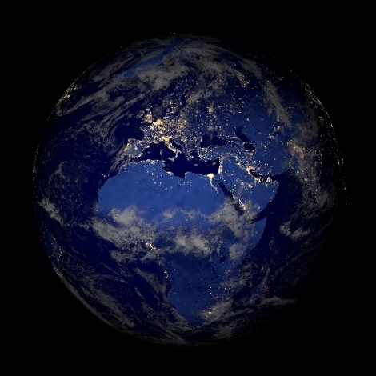  © iStock.com/MarcelC | global
© iStock.com/Maria Korneeva | -e Textilindustrie
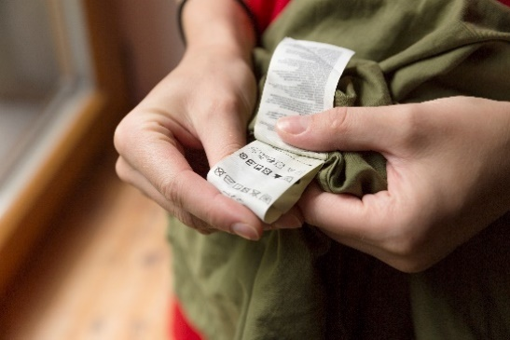  © iStock.com/artursfoto | -s Produktionsland
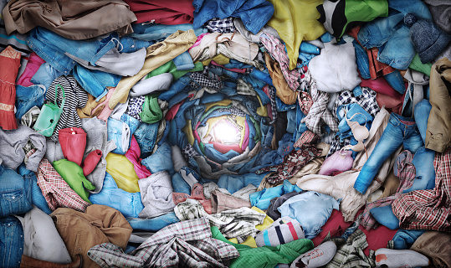  © iStock.com/artursfoto/urfinguss | katastrophal
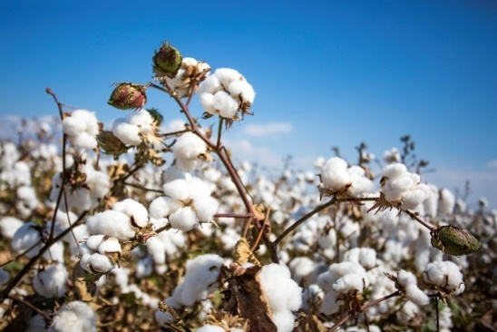  © iStock.com/Esin Deniz | -e Baumwolle
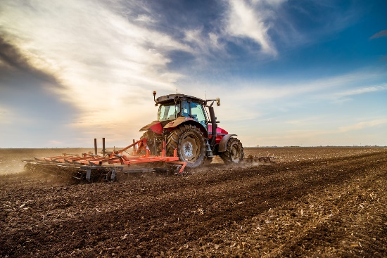  © iStock.com/oticki | anbauen
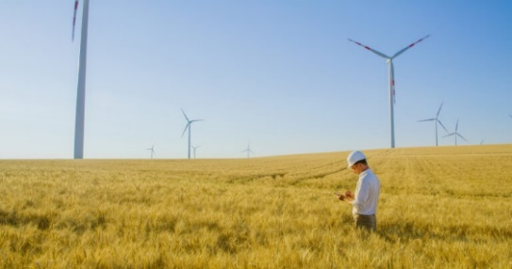  © iStock.com/SimonSkafar | -e Monokultur
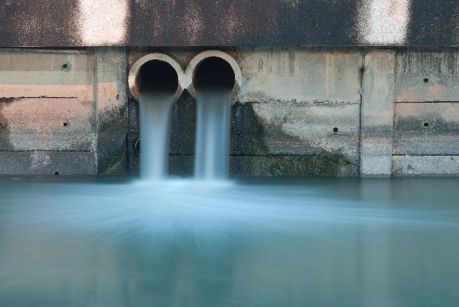  © iStock.com/jirapongb | -e Chemiekalie
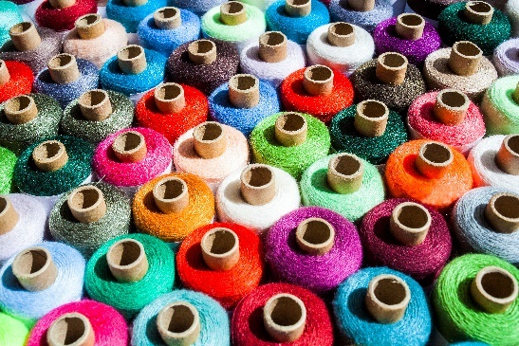  © iStock.com/SlobodanMiljevic | -s Garn
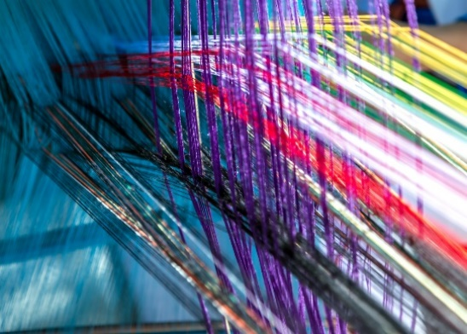  © iStock.com/Vladyslav Danilin | spinnen
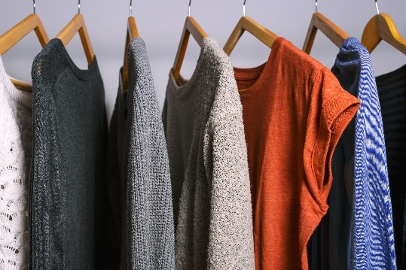  © iStock.com/CarmenMurillo | -r Stoff
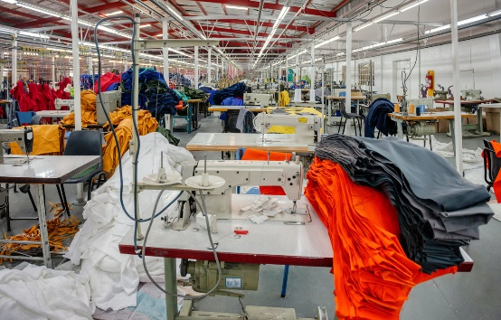  © iStock.com/poco_bw | -e Textilfabrik

